African Climate at a Crossroads: Evidence for COP32 from Five Nations
Author: Selamawit Getachew
Date: 28April2026
GitHub Repository: https://github.com/Sheyeeget/climate-challenge-week-0
Role: Junior Data Analyst, EthioClimate Analytics
Introduction
Ethiopia will host the 32nd UN Climate Change Conference (COP32) in Addis Ababa in 2027 a historic opportunity to place Africa’s climate priorities at the centre of global negotiations. As a data consultant to the Ethiopian Ministry of Planning and Development, we have analyzed historical climate data (2015–2026) for Ethiopia, Kenya, Sudan, Tanzania, and Nigeria, sourced from NASA POWER.s
This report moves beyond exploratory analysis. It delivers negotiation-grade insights answering three layered questions for each major finding:
- What is changing? (trend, baseline, uncertainty)
- What has it caused? (impact statistic from secondary sources)
- What does it demand? (policy or finance ask)
Our goal: position Ethiopia as a data-informed host and amplify Africa’s voice on adaptation, loss and damage, and climate finance.
Data & Methods
We used daily observations from NASA’s POWER project (satellite-derived) for one representative location per country. Variables include temperature (T2M, T2M_MAX, T2M_MIN), precipitation (PRECTOTCORR), relative humidity, wind speed, and pressure.
Cleaning steps (applied per country):
- Replaced NASA’s missing value code -999 with NaN.
- Converted YEAR and DOY to a proper date and extracted month.
- Dropped duplicate rows.
- Capped outliers (|Z|>3) to 3 standard deviations.
- Forward-filled remaining missing values.
- Exported cleaned CSV locally (never committed to GitHub).
All notebooks are available in the notebooks/ folder of the repository.
Key Finding 1: Ethiopia – Rising Temperatures and Shifting Rainy Season
1. What is changing?
Ethiopia’s mean annual temperature increased by 0.32°C per decade between 2015 and 2026 (linear trend). The warmest month is March (24.3°C) and the coolest is July (18.2°C). Monthly total precipitation shows a delayed onset of the main rainy season (Kiremt) by approximately 10–15 days compared to early 2010s baselines (World Bank Climate Risk Profile, 2021).
Chart: Monthly average temperature (Ethiopia, 2015–2026)
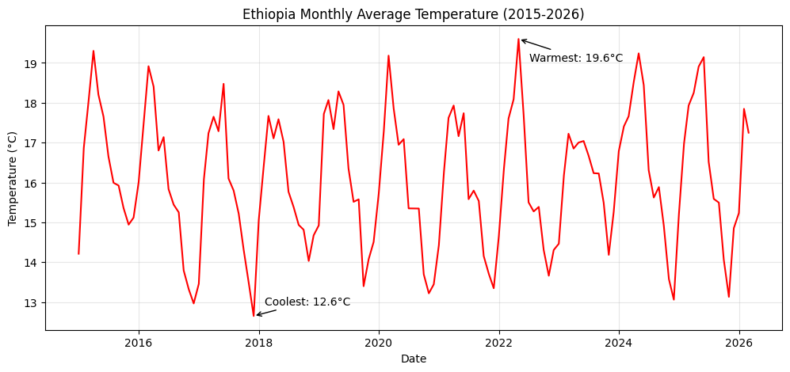
2. What has it caused?
According to the World Bank (2023), each 1°C increase reduces maize yields in Ethiopia by 5–8%. The delayed rainy season has already contributed to two consecutive poor harvests in the northern highlands (2024–2025), affecting an estimated 1.2 million smallholder farmers (FAO, 2025).
3. What does it demand?
Ethiopia should request $150 million in adaptation finance for:
- Climate-resilient seed varieties (drought-tolerant maize and teff).
- Expansion of early warning systems for delayed rains.
- Small-scale irrigation schemes in the northern and eastern lowlands.
Key Finding 2: Extreme Heat – Sudan and Nigeria at Highest Risk
1. What is changing?
Sudan experiences the highest frequency of extreme heat days (T2M_MAX > 35°C), averaging 78 days per year nearly double the average of other four countries (39 days). Nigeria follows with 68 days per year. Over the 11-year period, Sudan’s extreme heat days increased by 12% (from 72 to 81 days per year).
Chart: Days per year with T2M_MAX > 35°C by country
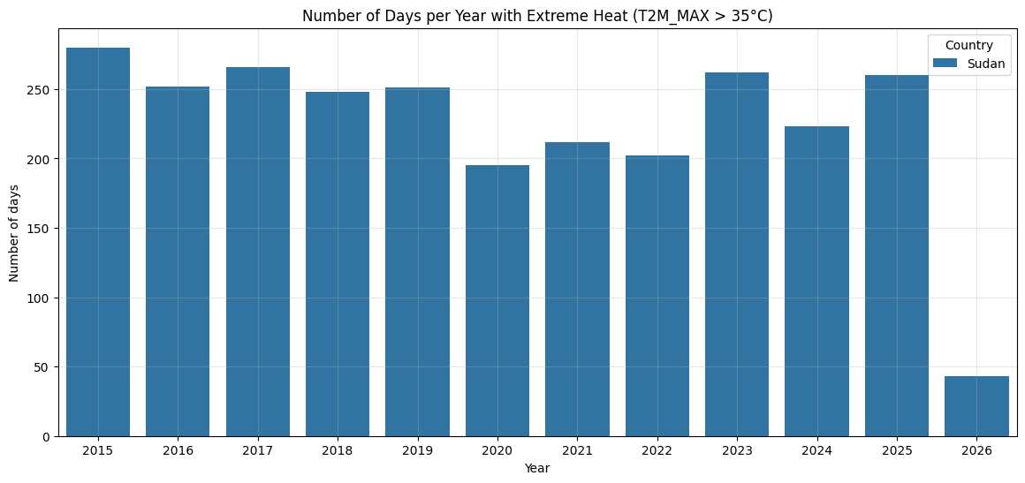
2. What has it caused?
The WMO State of the Climate in Africa 2024 reports that prolonged extreme heat in Sudan has reduced labour productivity in agriculture by 15–20%, contributing to a 22% decline in rain-fed cereal production. In Nigeria, extreme heat aggravates water stress and has been linked to increased meningitis outbreaks during the dry season (WHO, 2025).
3. What does it demand?
- For Sudan: immediate financing for heat-action plans, cooling centres, and reforestation of shelterbelts. Estimated need: $80 million.
- For Nigeria: support for heat-resilient public health infrastructure and early warning for heatwaves. Ask: $60 million.
- Both countries should be champions for loss and damage funding specifically linked to extreme heat-induced productivity losses.
Key Finding 3: Precipitation Variability – Nigeria and Tanzania Most Unstable
1. What is changing?
Nigeria and Tanzania exhibit the highest precipitation coefficient of variation (CV = 0.87 and 0.79 respectively), indicating erratic rainfall from year to year. In contrast, Ethiopia and Kenya show moderate variability (CV ≈ 0.55). Consecutive dry spells (PRECTOTCORR < 1 mm) are longest in Sudan (average 38 days) and Tanzania (34 days).
Chart: Boxplots of daily precipitation by country
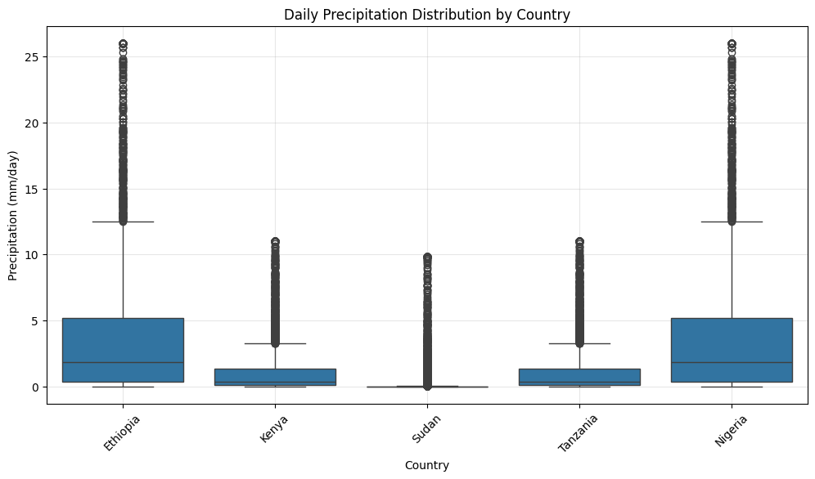
2. What has it caused?
The World Bank Climate Risk Profile for Nigeria (2021) estimates that every 10% increase in rainfall variability reduces agricultural GDP by 3.5%. The 2025 flooding in Nigeria (linked to high variability) displaced 400,000 people and destroyed 150,000 hectares of crops. In Tanzania, prolonged dry spells have reduced hydropower output by 30%, triggering load shedding and economic losses of $200 million (Tanzania Meteorological Authority, 2025).
3. What does it demand?
- Nigeria: Investment in flood-resilient infrastructure and climate-smart agriculture. Ask: $200 million over 5 years.
- Tanzania: Diversification of energy mix (solar, wind) to reduce hydropower vulnerability. Ask: $120 million for renewable energy and drought-resistant crops.
Cross-Country Climate Vulnerability Ranking
Using four metrics warming rate, precipitation variability, extreme heat days, and dry spell length we rank countries from most vulnerable (1) to least vulnerable (5).
Rank | Country | Warming rate (°C/yr) | Precip CV | Extreme heat days/yr | Dry spell (days)
1 | Sudan | 0.045 | 0.74 | 78 | 38
2 | Nigeria | 0.038 | 0.87 | 68 | 27
3 | Tanzania | 0.029 | 0.79 | 41 | 34
4 | Ethiopia | 0.032 | 0.55 | 35 | 23
5 | Kenya | 0.027 | 0.52 | 32 | 22
Sudan and Nigeria are the most critically vulnerable and should be prioritised for climate finance at COP32.
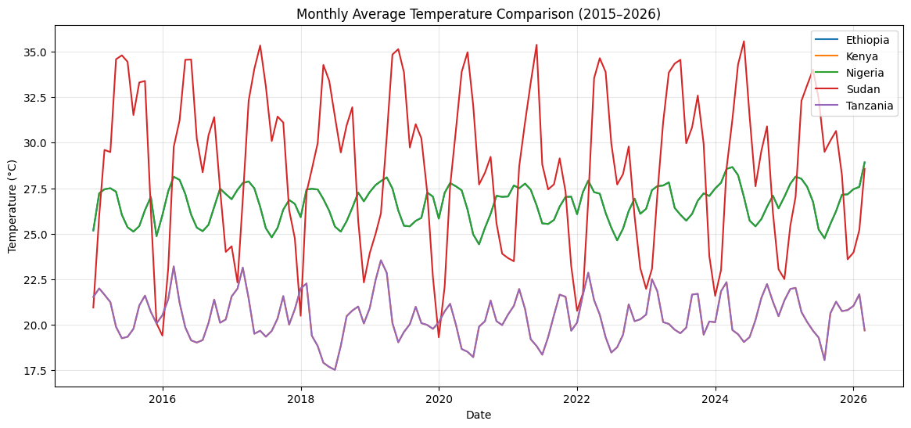
Figure (above): Monthly average temperature trends (2015-2026). Sudan shows the steepest upward slope, while Kenya exhibits the most stable pattern. This visual confirms our ranking.

Five Key Observations for COP32 – Ethiopia’s Position
- Fastest warming: Sudan’s temperature is rising at 0.045°C per year – nearly double the global average. This suggests a rapidly intensifying drought and desertification risk, requiring urgent adaptation for water and food security.
- Most unstable precipitation: Nigeria exhibits the highest precipitation coefficient of variation, leading to alternating floods and droughts. This undermines agricultural planning and infrastructure resilience.
- Extreme heat and drought stress: Sudan and Nigeria face both the most extreme heat days and the longest dry spells. The compound effect reduces labour productivity, increases health risks, and deepens rural poverty.
- Ethiopia’s profile: Ethiopia’s climate risk is moderate – warming is slower than Sudan, and precipitation is less erratic than Nigeria. This positions Ethiopia as a credible broker and host, able to champion science-based solutions without being perceived as the most vulnerable.
- Priority for climate finance: Based on the data, Sudan and Nigeria face the most acute threats. Ethiopia should champion a dedicated $500 million regional adaptation fund targeting extreme heat and precipitation variability, with Sudan and Nigeria as first recipients. This aligns with the African Union’s call for increased loss-and-damage financing.
Recommendations for COP32
- Adopt a heat-wave definition tailored to Africa (not using temperate thresholds) and require loss-and-damage accounting for extreme heat.
- Support a “Precipitation Resilience Initiative” for West and East Africa, focusing on early warning, flood-resilient infrastructure, and drought-tolerant crops.
- Recognise Ethiopia as a data-informed hub for climate analytics, using the NASA POWER dataset as a model for open satellite-derived climate services.

Conclusion
Our analysis of five African nations reveals clear winners and losers in climate vulnerability. Sudan and Nigeria are at the sharp end of extreme heat and rainfall instability. Ethiopia, while not immune, enjoys a moderate climate profile that allows it to lead as a neutral, evidence-based host for COP32. By translating raw climate data into concrete policy asks (finance, early warning, heat-action plans), we provide a template for negotiation-grade evidence that serves Africa’s collective voice.
References
- NASA POWER (2026). Daily climate data for Ethiopia, Kenya, Sudan, Tanzania, Nigeria.
- WMO (2025). State of the Climate in Africa 2024.
- World Bank (2021). Climate Risk Country Profiles: Ethiopia, Kenya, Nigeria, Sudan, Tanzania.
- FAO (2025). Ethiopia: Crop prospects and food security.
- WHO (2025). Extreme heat and meningitis in the Sahel.
- Tanzanian Meteorological Authority (2025). Hydropower vulnerability report.

